Enhanced Homomorphic Secret Sharing for Secure and Verifiable Cloud Data Protection
Mrs. T. Kavitha¹, Greeshma Sai D², Sree Abhilash J³ and Rakesh M⁴
¹Assistant Professor, Srinivasa Ramanujan Institute of Technology

^{2,3,4}Student, Srinivasa Ramanujan Institute of Technology
Department of Computer Science and Engineering,

Anantapur, Andhra Pradesh, 515001, India
kavitha.cse@srit.ac.in, 224g1a0523@srit.ac.in, 224g1a05a5@srit.ac.in, 224g1a0580@srit.ac.in
Keywords: Cloud Computing, Homomorphic Encryption, Secret Sharing, Secure Cloud Storage, Multi-Cloud Architecture, Privacy Preservation.
Abstract: The cloud computing system encounters a serious problem in terms of maintaining confidentiality, integrity, and secure access control of data within the single-cloud system that can be easily breached and may fail. This study suggests a stronger cloud data security program by proposing an Enhanced Verifiable Homomorphic Secret Sharing scheme. The goal is to come up with a safe and scalable multi-cloud structure that enables controlled access and verifiable services. The approach includes an AES encryption method employed, secret sharing to support the distributed storage, and homomorphic encryption to allow computation on the encrypted data. Experimental analysis proves better tolerance to failures, better protection of privacy and greater protection against unauthorized access than the use of conventional cloud storage methods. It is a privacy preserving and reliable solution to secure distributed cloud data management based on the proposed framework.

1 INTRODUCTION
In the digital world, cloud computing has become a very important tool of storing and processing large data. It offers such advantages as scalability, cost-saving, and remote access. Organisations and individuals are moving towards using cloud platforms to store sensitive data like personal data, academic data, and business data. Nonetheless, cloud computing also presents significant concerns about the privacy, accuracy and secure access to data.

In most existing cloud systems, information is stored and handled in a conventional encryption scheme. Although encryption helps in safeguarding data against inappropriate access, it generally interferes with safe calculation and the need to be decrypted prior to processing. Such a process may reveal confidential information. Also, the location of encrypted data on a single cloud platform poses a single point of failure that exposes the systems to data leaks, loss, or attacks.

In order to overcome these problems, such new cryptographic tools as secret sharing and homomorphic encryption became of great importance. Secret sharing separates data into multiple files and distributes them to different cloud environments, which boosts security and dependability. Homomorphic encryption enables calculation to be carried out on the encrypted data without revealing the original information. Nevertheless, most of the current approaches do not have means of assessing the correctness of the cloud operations.

Due to the increasing popularity of secure and distributed cloud solutions there is a stronger demand towards systems that guarantee confidentiality, verification and controlled access. In this project, a better Verifiable Homomorphic Secret Sharing framework of Cloud Computing is presented. This framework offers safe encryption of files, distribution of files to various clouds and privacy-protected computing. The system is also known to support user verification, administration control and verified access hence is appropriate in the secure and reliable management of data using a cloud-based platform.

2 PROBLEM STATEMENT AND OBJECTIVES
Most cloud computing systems do not allow users to fully rely on the security of the storage, processing, and access of their sensitive information. The existing cloud storage models apply the conventional encryption techniques securing data at rest, but they do not facilitate secure computation and distributed storage. Single-cloud systems increase the chances of leakage, illegal access and single points of system failure. Moreover, users do not have much understanding of the work of clouds, and it is difficult to check the integrity of data or identify manipulations.

The main objectives of this project are: (1) to develop a secure cloud infrastructure to assure the accessibility of encrypted data only by authenticated user and administrator identities, (2) to deploy effective cryptographic tools such as AES encryption, secret sharing, and homomorphic tools to assure data privacy, reliability, and trust in cloud computing infrastructure, and (3) to develop a scale-up multi-cloud architecture, which enhances data privacy, reliability, and trust in cloud infrastructures.

In addition to safety and trust, most of the existing cloud systems do not have centralized control and access control. The process of data management and verification is usually independent on the platforms resulting in inconsistent security policies and poor management by the administrators. Such an incongruence complicates the monitoring of user operations, the control of permissions, and the integrity of data over the long-term. A distributed, but centralized cloud architecture can help these issues greatly by storing verifiable and encrypted records that could be updated and verified in more than one cloud.

3 LITERATURE REVIEW
A number of scholars have examined the issue of cryptographic in order to enhance security in cloud computing. Secret sharing mechanisms have also been proposed that are verifiable to guarantee data integrity and accuracy in distributed cloud storage system (Zhang and Chen, 2017). Such approaches are constructive in gaining user confidence as they enable confirmation of data stored but in most cases do not have viable means of applying them in multi-cloud environments.

Secret sharing and access control-based secret sharing models of secure data storage have also been discussed in order to enhance confidentiality in cloud settings (Zhang and Wang, 2019). Although such mechanisms offer enhanced security against unauthorized access, they might not facilitate secure computation on encrypted data with complete protection.

Also, literature resources on cloud security models indicate issues with privacy preservation, scalability, and fault tolerance (Chhabra and Gupta, 2020). Nevertheless, with the level of improvement made, there are numerous systems available that lack the incorporation of encryption, verification, and management in one system. Therefore, an enveloping, scalable, and verifiable multi-cloud system that will ensure confidentiality and transparency of operations is needed.

4 PROPOSED SYSTEM
The proposed system proposes an encryption algorithm that incorporates AES encryption algorithm, verifiable secret sharing algorithm and homomorphic encryption algorithm to establish a secure and verifiable cloud computing system. First, each file of the user is encrypted by Alternative Encryption Standard (AES). That is followed by dividing it into encrypted portions using secret sharing methods. These shares are distributed and stored in two different cloud environments Cloud A and Cloud B. Such an architecture provides confidentiality, redundancy, and single-point failure protection. Any given cloud cannot be reassembled to give meaningful data by unauthorized users.

There are three layers in the system, which include: a user interface layer, a cryptographic processing layer and a cloud storage layer. The user interface layer is used to handle the registration of users, authentication, files uploading, and access. The cryptographic layer of processing works with encryption, secret sharing and homomorphic. The file shares are encrypted and stored in the cloud storage layer that provides security to access requests on retrieval.

Scalability can also be done in the proposed system. The capacity of the cloud resources can be expanded with the increase of the amount of data and users. Cloud administrators are able to authorize users, keep track of file activity and access permission without manipulating the underlying data. Encryption plus verifiable secret sharing together with homomorphic computation ensure the privacy, integrity and transparency of the data. This renders the system appropriate in a secure and distributed cloud computing system.

SYSTEM ARCHITECTURE AND WORKFLOW
The suggested system architecture provides an efficient method of encrypted data storage and retrieval on the cloud computing platforms. It consists of three major sections, the User Module, the System Processing Module, and the Cloud Storage Module. Precaution taken by secure authentication ensures that the system is only accessible to authorized users as well as cloud administrators. This avoids illegitimate activities and ensures the privacy of data.

The system begins by registering and logging in users with uploading of files after that. Encryption of uploaded files is done using AES algorithm and split into several shares through secret sharing methods. Such encrypted shares are allocated and stored in two different cloud environments Cloud A and Cloud B. This configuration guarantees redundancy and avoids loss of data or single point failure. The users may access their encrypted files, have the option to ask to be decrypted, and control their profile in a secure interface.
The administrators of clouds can use the system by means of a special module, which allows viewing users, controlling authorized access, tracking file activity, and applying security policies. The process of decryption and file reconstruction will be completed after acquiring the right authorization through a combination of the shares of both clouds. As shown in Figure 1, the proposed system integrates encryption, secret sharing, and multi-cloud storage to ensure secure data management. With this architecture, there is guaranteed confidentiality, integrity, verifiability and controlled access thereby rendering the system appropriate to secure and scalable cloud data storage and computation.

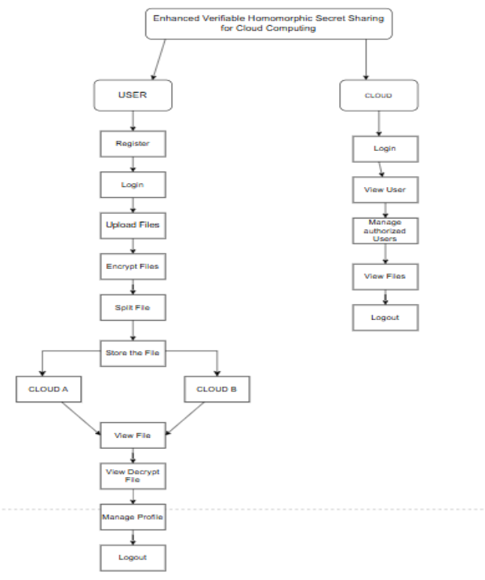
Figure 1: System architecture of the proposed multi-cloud secure framework.

6 RESULTS AND DISCUSSION
The proposed system will provide safe storage of data on the cloud through encrypting files and spreading them across various cloud systems through verifiable secret sharing. Through experimental observations, it is clear that only the authenticated users will be able to make the uploading, viewing and decrypting of files. Such an arrangement helps to avoid intrusion and information leakage. Homomorphic encryption is included ensuring confidentiality of user privacy during encrypted data operations.

The system is more data integrity, fault tolerance and administratively controlled as compared to conventional cloud storage models. The user reviews indicate that the site instills confidence and is not difficult to navigate. Effective user management and monitoring are beneficial to administrators. In sum, the system offers a reliable and scalable system to have secure cloud computing which also maintains privacy.

7 CONCLUSION AND FUTURE WORK
The Enhanced Verifiable Homomorphic Secret Sharing for Cloud Computing system is a secure system to ensure the safety of sensitive data in the cloud environment. System integrity, which ensures that the data is unchanged throughout its processing, and the confidentiality and controlled access of the data are maintained using cryptographic methods that, in turn, permit distributing the data across several clouds.

The multi-cloud system enhances the level of reliability in that it eliminates single points of failure. The dual-access model provides users with an opportunity to ensure the safety of encrypted files and cloud administrators with the ability to authorize permissions and track actions. Privacy-preserving computation maintains the data in an encrypted state even when it is being processed.

Further developments can be targeted at making homomorphic encryption more efficient and include more intelligent threat detection as well as improved access control mechanisms. Modernization of the system to fit the latest technologies will also enhance security and scalability of the system in the modern cloud computing setups.

REFERENCES

Boneh, D., & Freeman, L. (2011). Homomorphic errorful learning encryption: Theory and practice. In Advances in Cryptology European Conference on Cryptography 2011 (pp. 1–18). Springer Berlin Heidelberg.
Chhabra, S., & Gupta, P. (2020). An analysis of cloud computing security models and their issues. International Journal of Computer Applications, 175(10), 175(10) 175(10) 175(10) 175(10) 175(10) 175(10) 175(10) 175(10) 175(10) 175(10) 175(10) 175(10) 175(10) 175(10).
Chow, S. S., & Xie, M. (2012). AES encryption and its usage in cloud computing. IEEE Transactions on Cloud Computing, 3(2), 144156.
Gennaro, R., & Jarecki, S. (2012). The cloud and homomorphic encryption. IEEE Computer, 45(3), 14–23.
Gentry, C. (2009). A completely homomorphic encryption system. Stanford University.
Hwang, S., & Kwon, S. (2016). Cloud computing environment in the storage and sharing of verifiable data. IEEE Transactions on Cloud Computing, 4(2), 135146.
Lindell, Y., & Pinkas, B. (2009). Privacy preserving-data mining with secure multiparty computation. Journal of Privacy and Confidentiality, 1(1), 3658.
Prasanna, V. K., & Kumar, N. (2018). Survey on cryptographic techniques of data security and privacy in cloud computing. Future Generation Computer Systems, 78, 457467.
Rivest, R. L., Shamir, A., & Adleman, L. (1978). One way of getting digital signatures and the public-key cryptosystems. Communications of the ACM, 21(2), 120–126.
Shamir, A. (1979). How to share a secret. Communications of the ACM, 22(11), 612–613.
Wang, Y., & Li, J. (2015). An overview of the topic of cloud computing security and solutions. International Journal of Computer Science and Network Security, 15(1), 21-29.
Wazid, M., & Younis, M. (2017). Security concerns to cloud computing: Survey and challenges. International Journal of Cloud Computing and Services Science, 6(1), 14-22.
Zhang, H., & Chen, X. (2014). Multi-cloud storage platform to ensure high-level data protection and privacy. International Journal of Cloud Computing and Services Science, 3(4), 1-10.
Zhang, Z., & Chen, Y. (2017). Cloud computing secret sharing which can be verifiable. IEEE Access, 5, 11838–11847.
Zhang, Z., & Wang, H. (2019). Safe data storage and access control in the cloud computing by the means of secret sharing. International Journal of Information Security, 18(1), 1–17.

